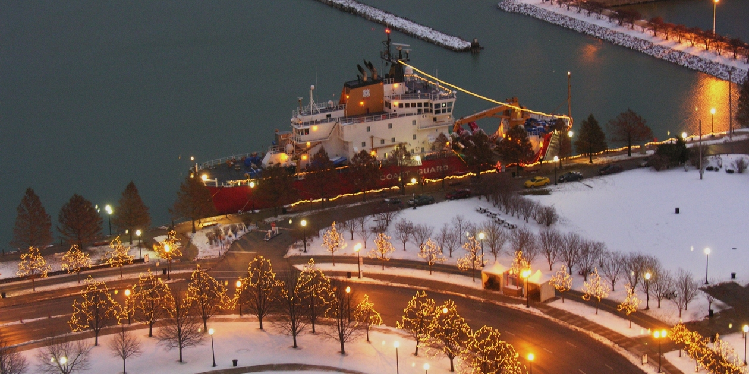

U.S. Coast Guard Cutter Mackinaw docked at Navy Pier, Chicago
December 6th, 2008
(Photo by Chicago’s Christmas Ship Committee)

